1. **Introduction**

This project is aimed to use android programming to create a program with CPU scheduling algorithm and Main Memory allocation as the functions. Throughout the whole project, we put in a lot of effects and developed a mobile application that can simulate CPU scheduling algorithm FCFS and Priority as well as memory allocation best-fit method.

1. **Task allocation/Theoretical background**

|  |  |
| --- | --- |
| Jeff | FCFS |
| Karthik | Best-Fit |
| Joseph | Non-Preemptive Priority |
| Laddie | First-Fit |

* 1. **First-Come-First-Serve**

First come, first served (**FCFS**) is an operating system process scheduling algorithm. It executes requests and processes based on the arrival time and does not take the burst time into account.

* 1. **Non-Preemptive Priority**

Priority scheduling is another scheduling algorithm in batch systems. Each process will be assigned with a priority. It executes requests and processes based on the priority and arrival time. In the case where the priority is the same, it will execute using the FCFS algorithm.

* 1. **Best-Fit**

The best fit deals with allocating the smallest free partition which meets the requirement of the requesting process. This algorithm first searches the entire list of free partitions and considers the smallest hole that is adequate. It then tries to find a hole which is close to actual process size needed.

* 1. **First-Fit**

In the first fit approach is to allocate the first free partition or hole large enough which can accommodate the process. It finishes after finding the first suitable free partition. Fastest algorithm because it searches as little as possible.

1. **GUI**
   1. **Main**

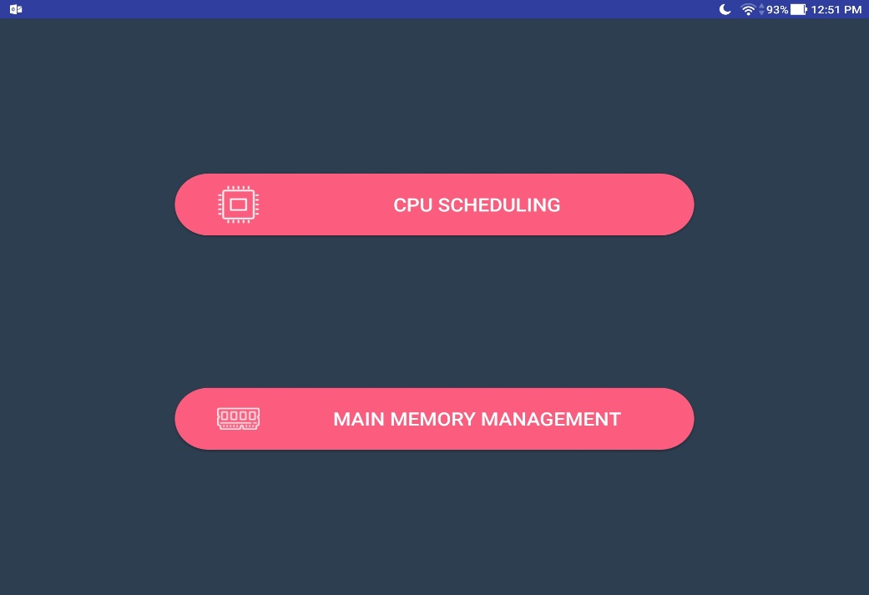

This main page allow users to select CPU scheduling and main memory.

* 1. **CPU scheduling**
     1. **Selection**

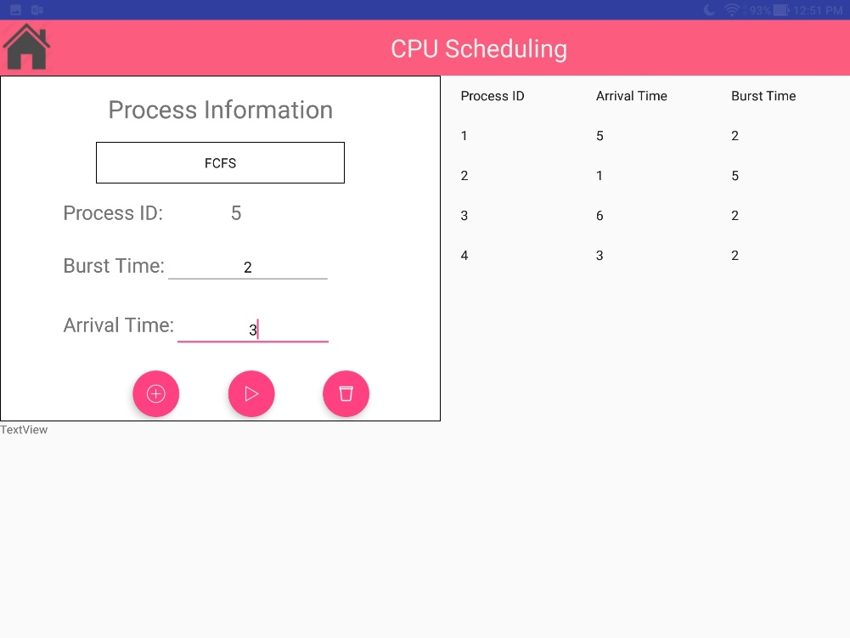

User can select either FCFS or priority scheduling from the spinner. After that user can add the burst time and arrival. If priority is selected user can add the priority to the process. After adding, the process get are added will be displayed on the gridview. Users can clear the list by pressing the bin button. AWT and ATT will be showed on a pop up after user press the compute button in the middle.

* + 1. **First-Come-First-Serve**

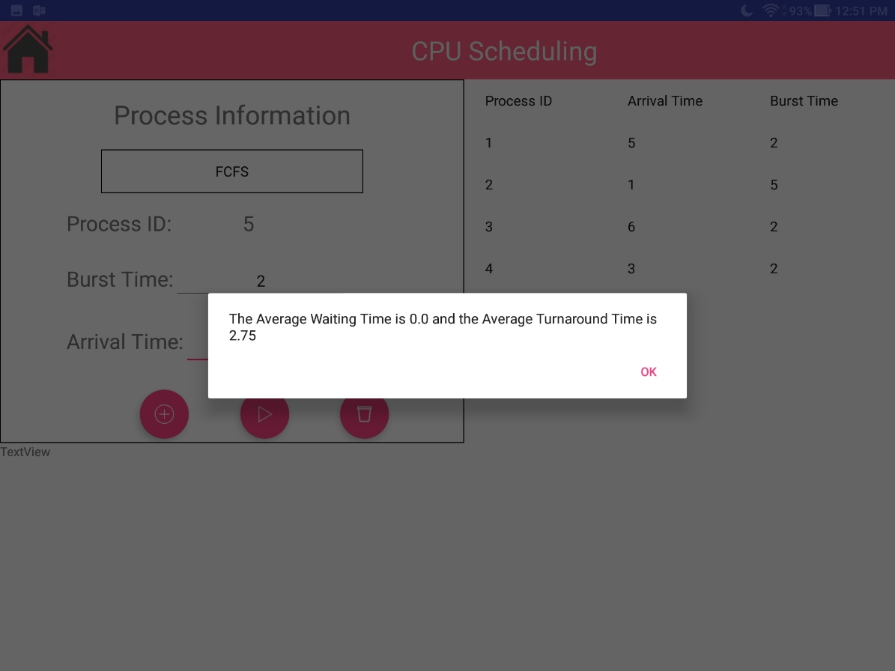

* + 1. **Priority**

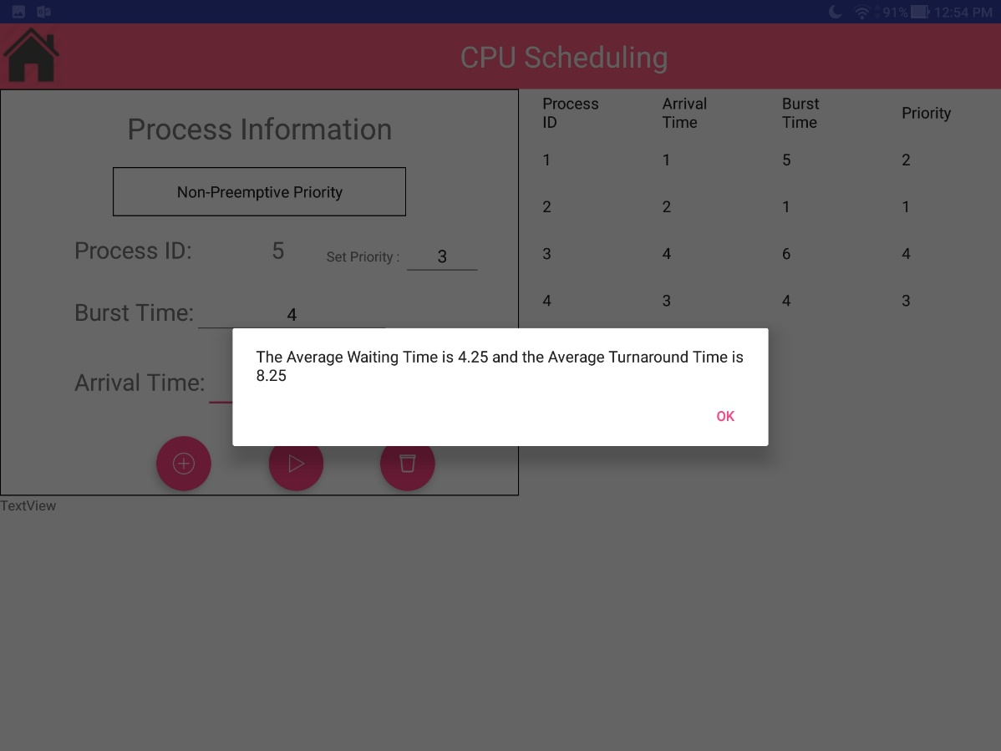

* 1. **Main Memory allocation**
     1. 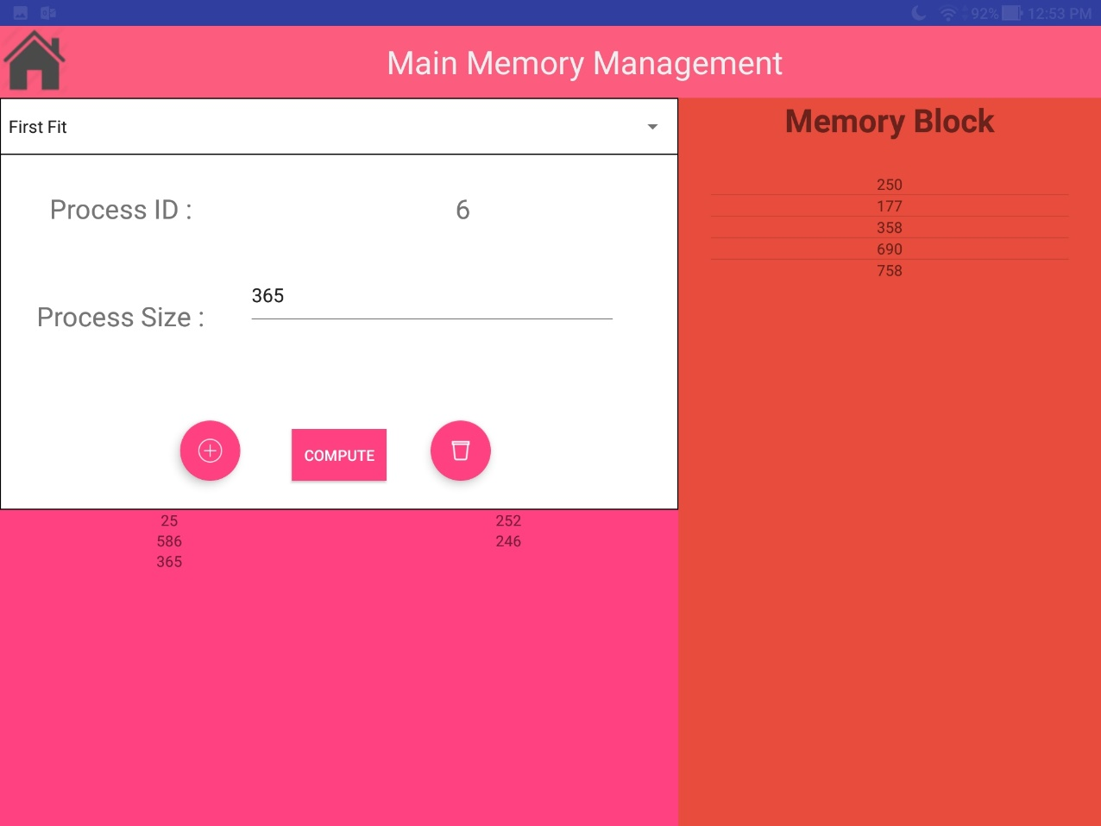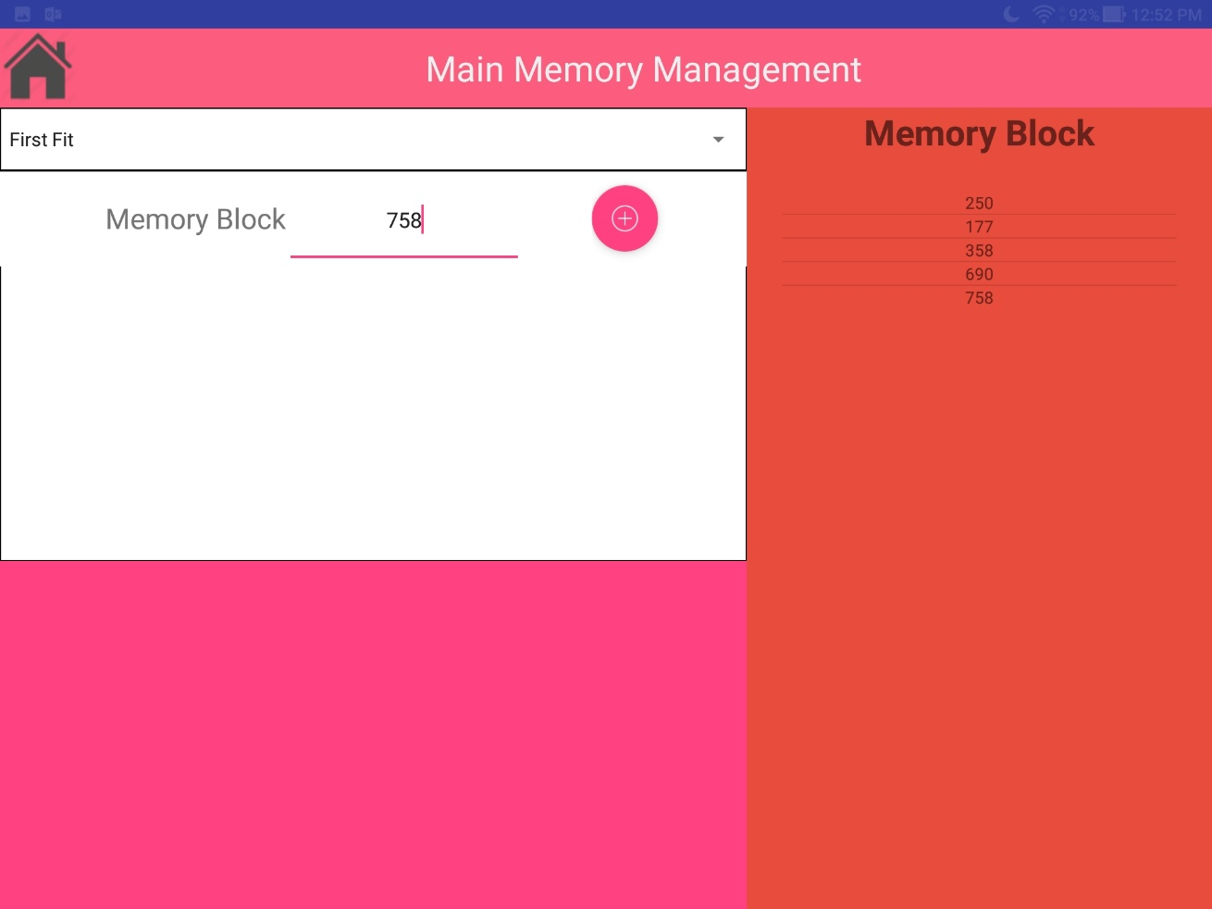**Add memory blocks**

Swipe right here

This page allows user to add the memory block need for the memory allocation. Before adding, user can select either the first-fit or the best-fit. After adding they need to swipe right to add the process. User can clear the list by pressing the bin button or press the compute button for the external and internal fragmentation. Results will appear on a pop up.

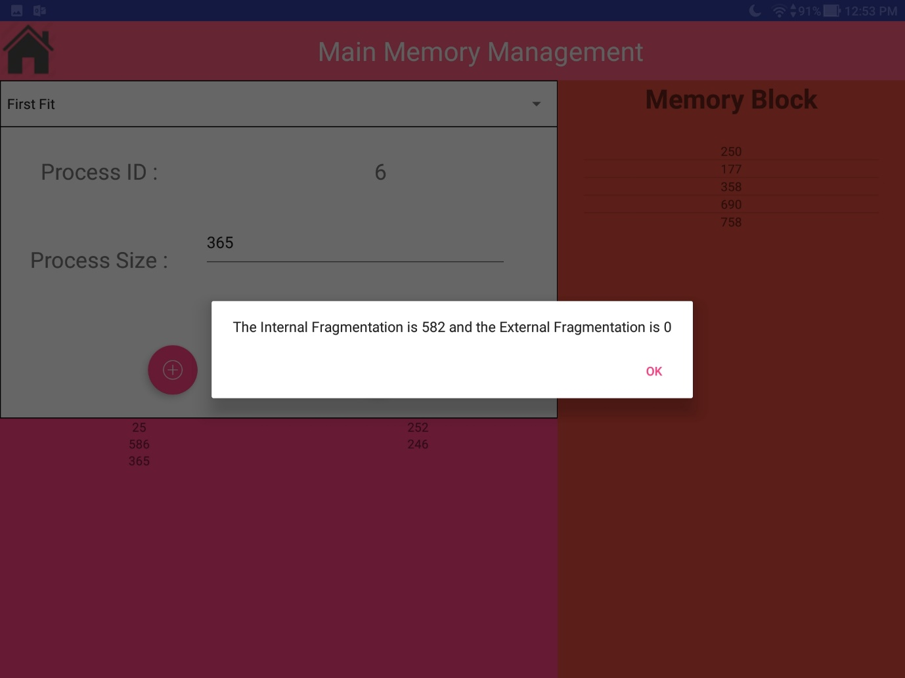

1. **Flow chart** 
   * 1. 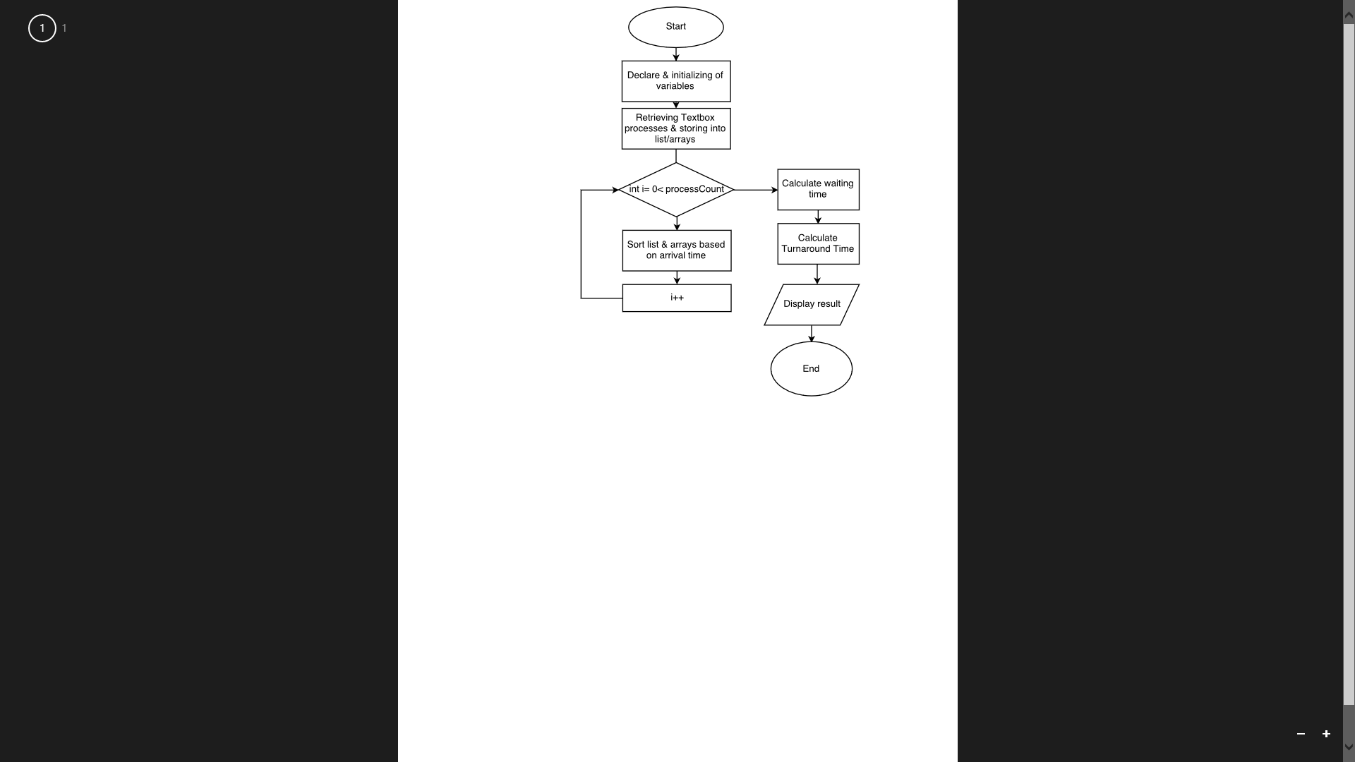**First-Come-First-Serve**
     2. 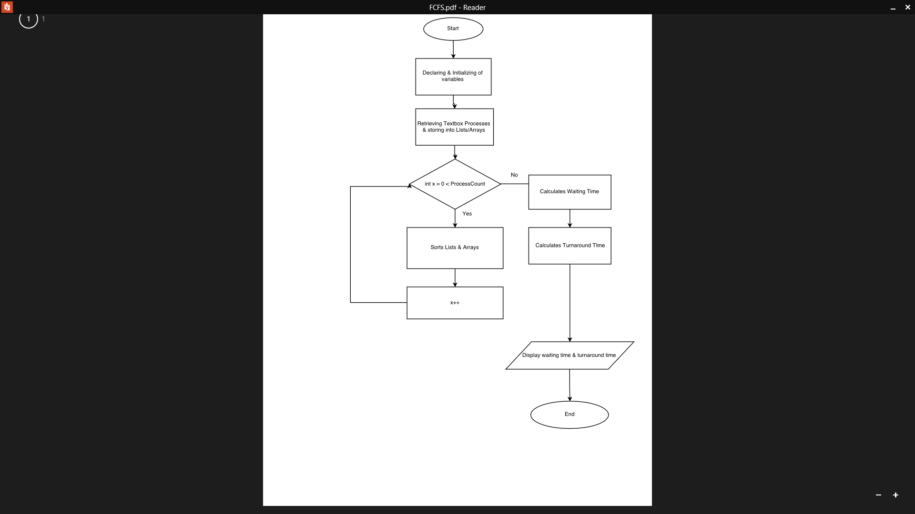**Priority**
     3. 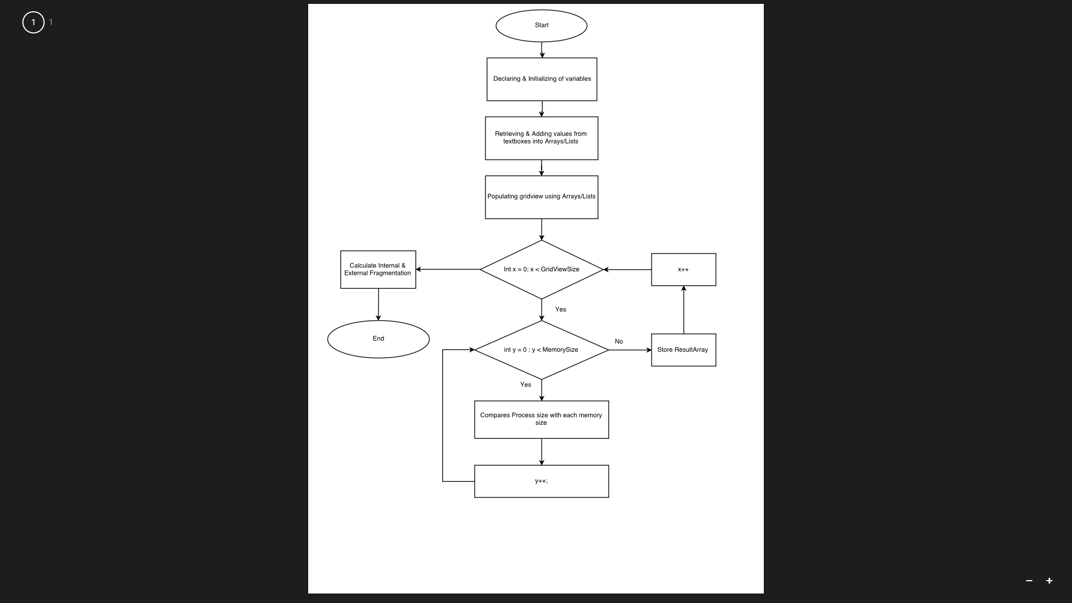**Best-Fit**
     4. **First-Fit**

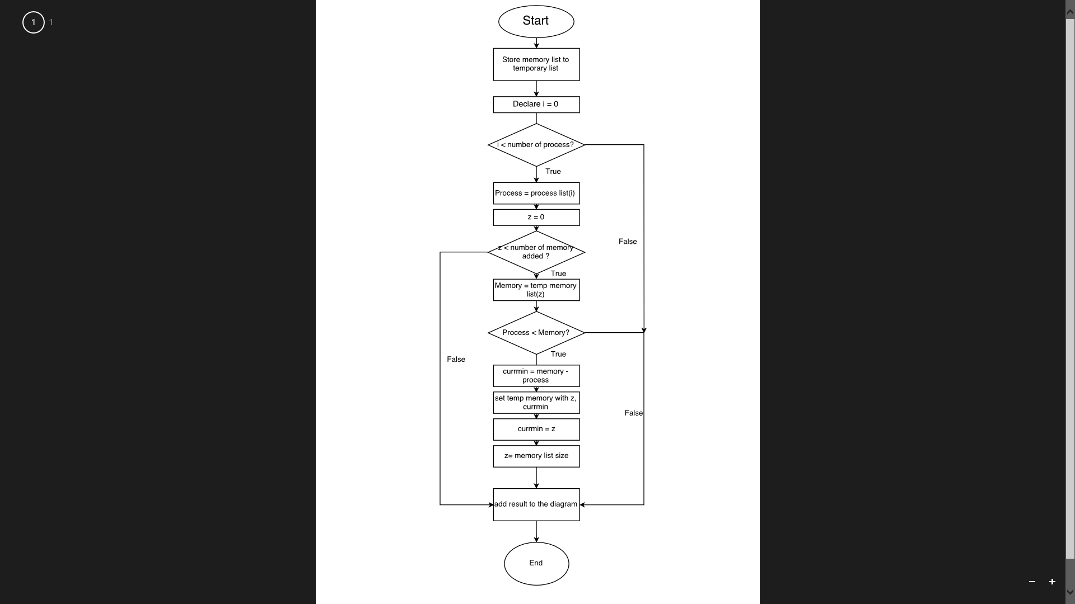

1. **Conclusion**

Our team successfully developed First-come-first-serve (FCFS), non-pre-emptive priority and best-fit using Android Studio. We also created one addition feature which is the First-fit. Additional algorithm and gantt chart will make the program more versatile